**EXPERIMENT – 1**

NAME: NIHARIKA AGRAWAL

COURSE: AI&ML

BATCH: 4

ROLL NO: R177219122

SAP ID: 500075359

LINEAR SERACH

ALGORITHM

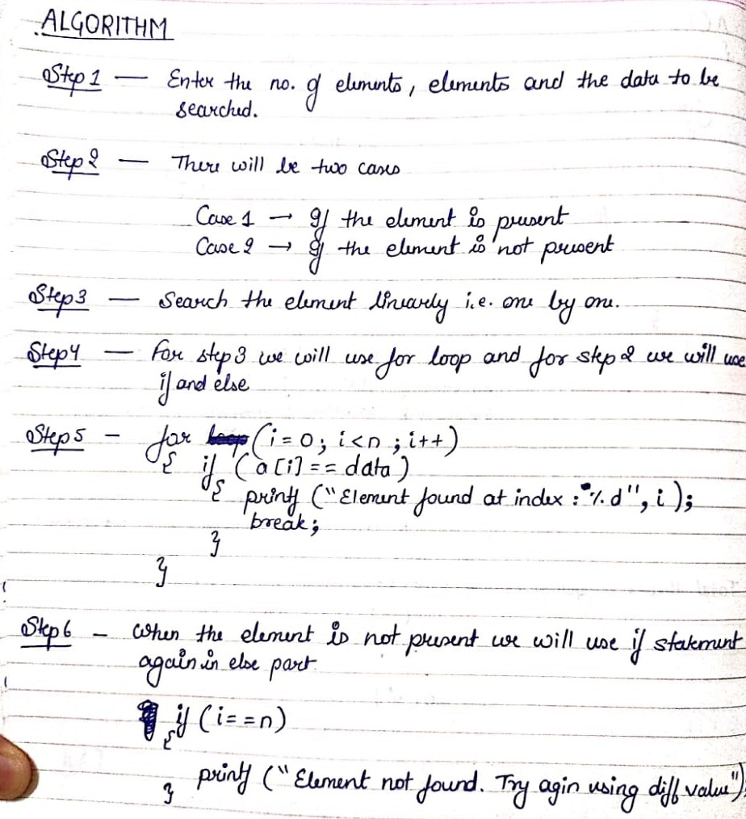

CODE

#include<stdio.h>

int main()

{

int i,n,element;

printf("Enter the number of elements :");

scanf("%d", &n);

int array[n];

printf("Enter the elements : \n");

for(i=0;i<n;i++)

{

scanf("%d", &array[i]);

}

printf("Enter the element to be searched :");

scanf("%d", &element);

for(i=0;i<n;i++)

{

if(element == array[i])

{

printf("Element is present in array at position: %d",i);

break;

}

else

{

if(i==n)

printf("Element not found. try again using different value.");

}

}

return 0;

}

OUTPUT

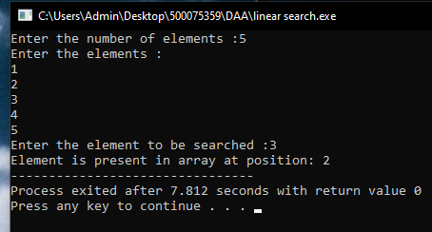

PATTERN MATCHING

ALGORITHM

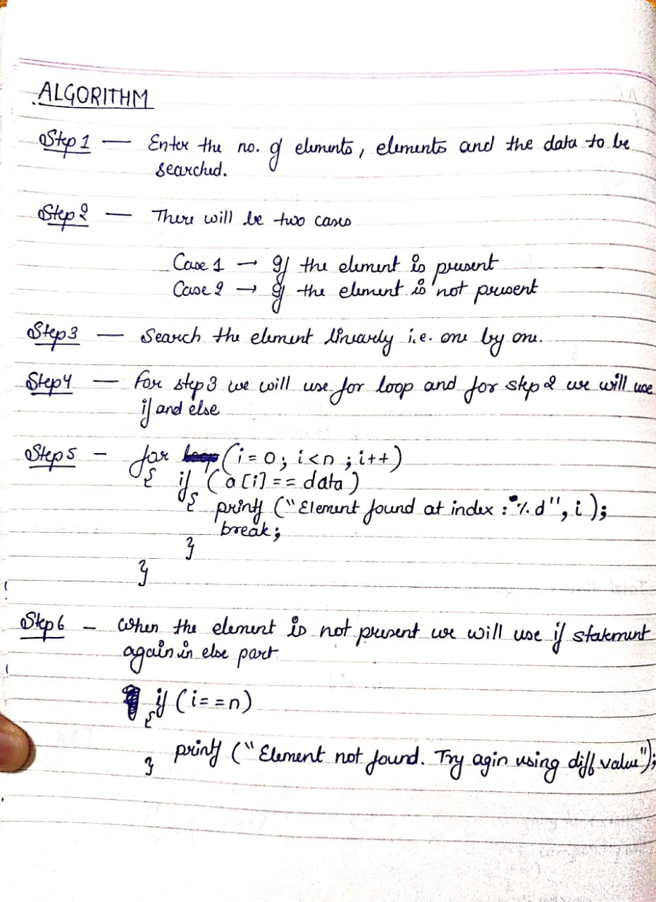

CODE

#include<stdio.h>

#include<string.h>

char t[100],p[50];

int brute_force();

int main()

{

int pos;

printf("Enter the Source String: ");

scanf("%s",t);

printf("Enter the pattern: ");

scanf("%s",p);

pos = brute_force ();

if(pos==-1)

printf("%s pattern not found in text",p);

else

printf("%s pattern found at index: %d",p,pos);

}

int brute_force()

{

int n,j,m,i;

n=strlen(t);

m=strlen(p);

for(i=0;i<n;i++)

{

j=0;

while(j<m && t[i+j]==p[j])

{

j++;

if(j==m)

return i+1; //pattern found

}

}

return -1; //pattern not found

}

OUTPUT

